# ADHOC TESTING

Testing the application randomly is called Adhoc Testing wherein we don’t refer any kind of formal document like test cases or scenarios.

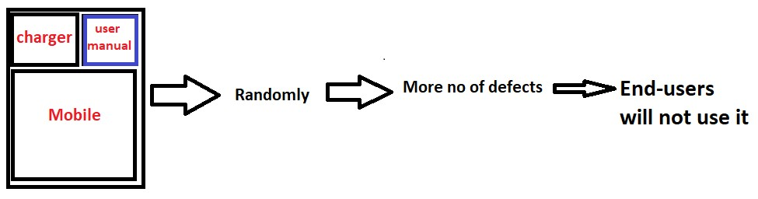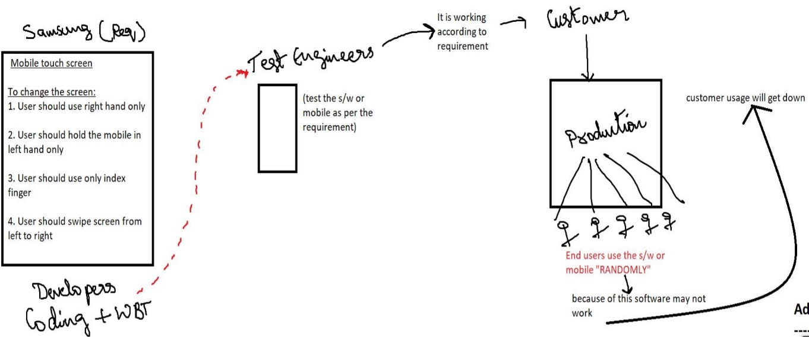

Adhoc Testing

**Why do we do Adhoc Testing?**

1. Chances are there when the product is launched end users might use the application randomly and find defects, in order to avoid that test engineer should do Adhoc Testing.
2. If you see the requirement and test the application, no. of defects which you are going to catch will be less (so think out of box to catch more defects)
3. Since requirements are not followed by the end users, we should do Adhoc Testing. We do this to have better test coverage.
4. The intention of doing Adhoc testing is to somehow break the product.

**How to do Adhoc testing?**

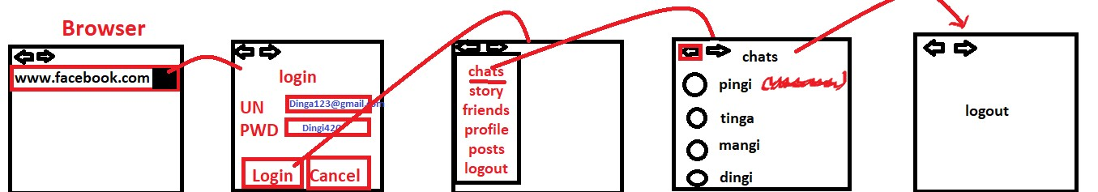

Login as User, click on compose fill the details for all fields click on send, logout. Click on the browser back button and check whether the login page should be displayed or the application should ask to enter UN and PWD.

**When do we do Adhoc testing?**

1. When the product is functionally stable then we should think about Adhoc testing.
2. When we are doing smoke testing, we should not do negative testing/Adhoc testing. If you do this you will not be able to test basic or critical features.
3. Whenever the testing team is free they should spend time doing Adhoc testing.
4. Whenever we are doing FT/IT/ST, if we get some Adhoc scenarios we should pause our regular testing & do Adhoc testing, if we get too many scenarios we should document it & execute it when we get time (it is not a formal document like test case)